Lab 3

1, Please read the train.csv file into R and store the data in a variable called “X”.

https://www.kaggle.com/c/home-depot-product-search-relevance/data

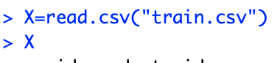

2, Write a function, called “distinct_relevance”, to count how many distinct values are in the column “relevance”? So when we call the function, it returns the desired results:

distinct_relevance (vect = X$relevance);

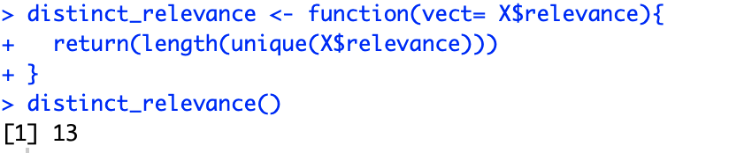

or

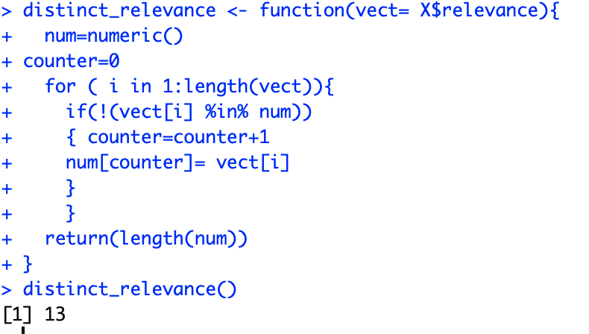

3, Write a function, called “count”, to count the number of appearances of a value, e.g. 3, in the column “relevance”, so when we call the function, it returns the desired results:

count(vect = X$relevance, value=3);

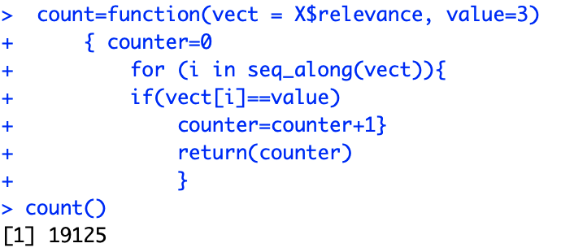

or

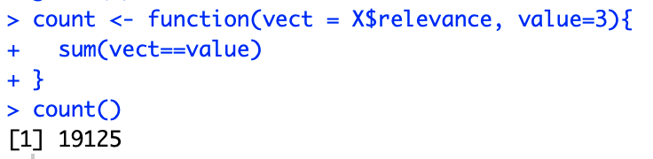

(For Q2 and Q3, please do not use existing R packages or functions.)

4, Compare the results with R function: table()

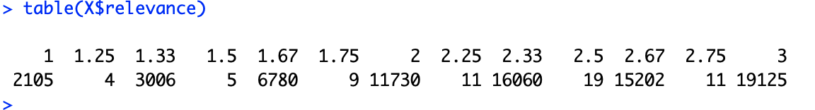

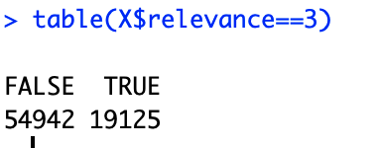

5. Pi can be computed by adding the following terms (<http://en.wikipedia.org/wiki/Pi>):

[Pi expansion.png](http://cs.smith.edu/dftwiki/index.php/File:Pi_expansion.png)

How many terms does it take to get the first 3 digits to be correct, 3.14? Write an R function getPi(N) to compute it, where *N* specifies the first N digits to be correct, and returns #terms.

